COMP 441 — Laboratory 1
Environment Setup & Manual Defect Hunting
Course: Software Analysis and Testing |
Student name: Amantle Dikoloti Student ID: 23017837
Project: task-manager-sample-repo (Python) |

1. Objective and method
Configure the Python testing environment, run the provided task-manager application, manually inspect source code for suspected defects, and record the existing automated test outcomes. The defect log captures both confirmed test failures and issues inferred from code inspection; source files were not changed during this lab.

2. Environment setup
Tool | Observed version or status
Git | 2.53.0.windows.2
Python | 3.14.7
pytest | 9.1.1
Dependencies | requirements.txt installed; pip reported required packages already satisfied
Editor | VS Code (observed in screenshots)
AI assistant | ChatGPT used to explain code and analyse defects

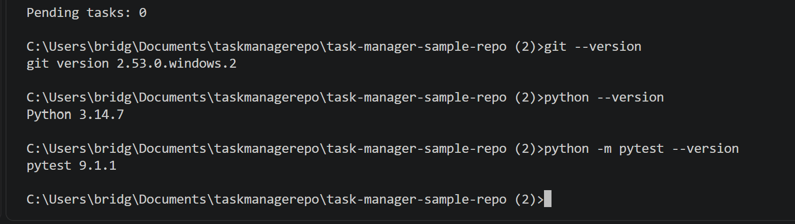
Figure 1. Terminal capture of installed Git, Python and pytest versions

3. Application execution and baseline test results
From the project folder, the application was run using: python -m app.cli. The observed output was "Loaded 0 tasks" and "Pending tasks: 0". This verifies that the application starts successfully when no task file is present; it does not demonstrate reporting with a non-empty task list.
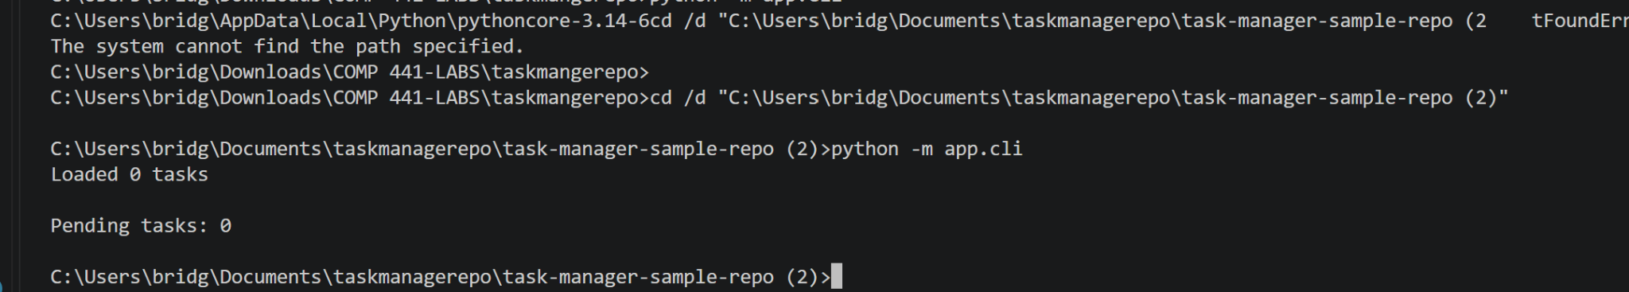
Figure 2. Application execution in the correct project directory.
Existing suite command: python -m pytest -v (repeated with --tb=short). Results: 6 collected; 4 passed; 2 failed.
Test | Result
test_add_task_creates_task | PASS
test_complete_task_marks_done | PASS
test_get_pending_tasks_includes_first_task | FAIL — expected 2, received 1
test_average_priority_of_empty_list | FAIL — ZeroDivisionError
test_calculate_discount_for_premium_user | PASS
test_calculate_discount_for_regular_user | PASS

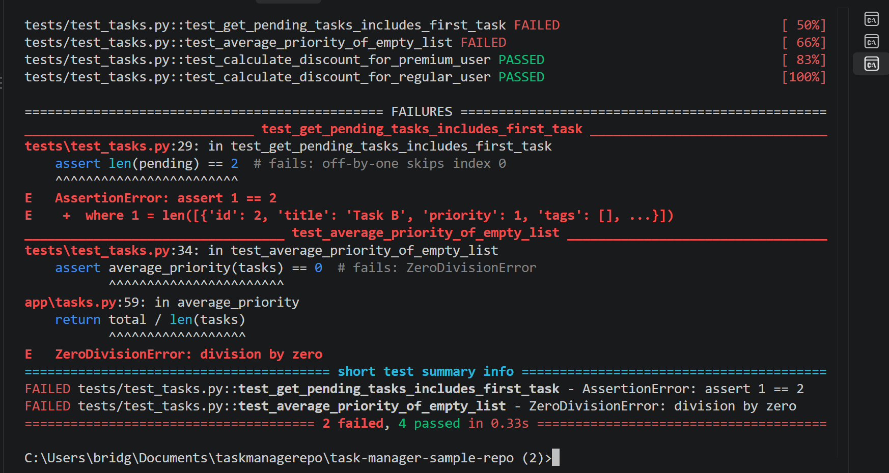
Figure 3. Failing test assertions: incorrect pending-task count and division by zero.

4. Defect log (manual inspection)
Severity ratings are preliminary. D01 and D02 were confirmed by test execution; D03–D10 were identified by reviewing the source code and should be verified with targeted tests or contextual requirements before being treated as confirmed production defects.
ID | File / line | Description / basis | Severity
D01 | app/tasks.py:48 | Iteration begins at 1 (range(1, len(tasks))), omitting task at index 0 from pending results. Test failed. [test-confirmed] | Medium
D02 | app/tasks.py:59 | Average priority divides by len(tasks) without checking whether the list is empty; raises ZeroDivisionError. Test failed. [test-confirmed] | Medium
D03 | app/tasks.py:11–13 | load_tasks opens a file without with or a close call; the handle may be left open. | Low
D04 | app/tasks.py:12 | json.load has no handling for invalid JSON; corrupted storage may crash task loading. | Medium
D05 | app/tasks.py:23,29 | Mutable default tags=[] can be shared by tasks created without explicit tags; later mutation can affect more than one task. | Medium
D06 | app/tasks.py:26 | Task IDs use len(tasks)+1; removing an earlier task may cause a newly added task to reuse an existing ID. | High
D07 | app/storage.py:11 | Report concatenates string + task["id"] (created as int), likely raising TypeError when at least one task exists. | High
D08 | app/storage.py:26 | SQL filter is inserted directly by string concatenation; potential SQL injection if executed. | High
D09 | app/storage.py:18–21 | Due date at midnight is compared to current clock time; a task due today can incorrectly yield -1 days. | Medium
D10 | app/storage.py:4 | API-key-like string is hardcoded in source (appears to be a sample/test key). Unsafe practice for real credentials. | Low

Additional observation: app/cli.py lines 2–3 import save_tasks and add_task but do not use them. This is a likely linter warning, not necessarily a behavioural defect.

5. Manual versus automated detection
Automated tests directly revealed D01 and D02 by checking expected results. A linter would likely report the unclosed file pattern (D03) and mutable default argument (D05), depending on its enabled rules. Input validation, identifier reuse (D06), incorrect date interpretation (D09), and query construction (D08) call for contextual manual review and/or purpose-built tests. The two existing failures alone do not demonstrate the remaining findings.

6. AI assistant configuration and confirmation
Assistant: ChatGPT (coding question about the project answered in this conversation).
question: "Why does test_get_pending_tasks_includes_first_task fail?"
Recorded answer: the loop range(1, len(tasks)) starts at index 1, so the task at index 0 is never considered. Iterating from index 0 or iterating directly over tasks would correct the omission.
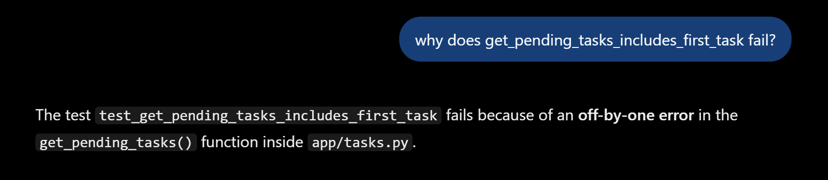

7. Reflection / discussion
The failing tests exposed the skipped first pending task (D01) and the division-by-zero problem (D02) quickly because both inputs had explicit expected outputs. Static linting can help identify coding patterns such as mutable default arguments and file-handle management. However, duplicate identifier generation (D06) requires thinking through task deletion and later creation; the SQL query construction (D08) requires considering untrusted input, while the due-date calculation (D09) requires checking the meaning of "days remaining." These examples show why manual reasoning and targeted tests complement automated tools.
My own observation / revision is that I observed that the `get_pending_tasks()` function skips the first task because the loop starts at index 1 instead of 0. This caused the test to fail, returning one task instead of two. I would correct the loop to start at index 0 and rerun the test to confirm the fix.

8. Conclusion
The Python environment and baseline command-line application were verified. Six existing tests executed, four passed and two failed. Ten code-review findings were documented, including two confirmed failures. No fixes have been applied in this baseline lab.

Appendix A — Source-code inspection evidence
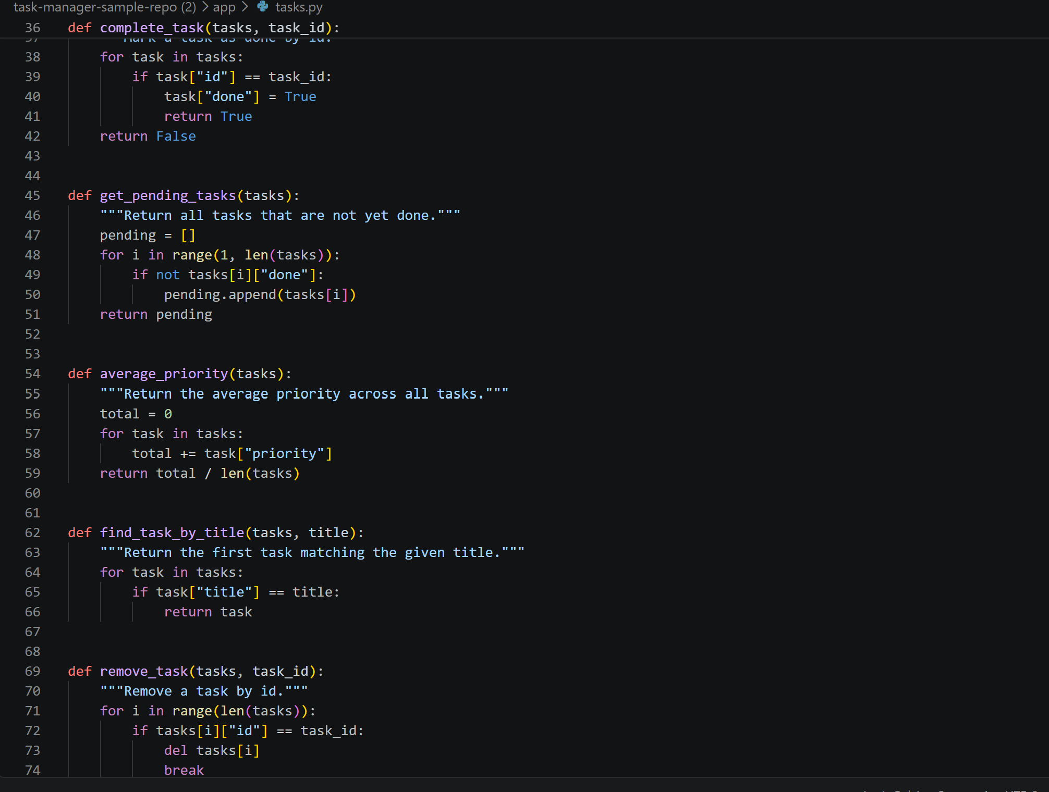
Figure 4. app/tasks.py, including D01 at line 48 and D02 at line 59.
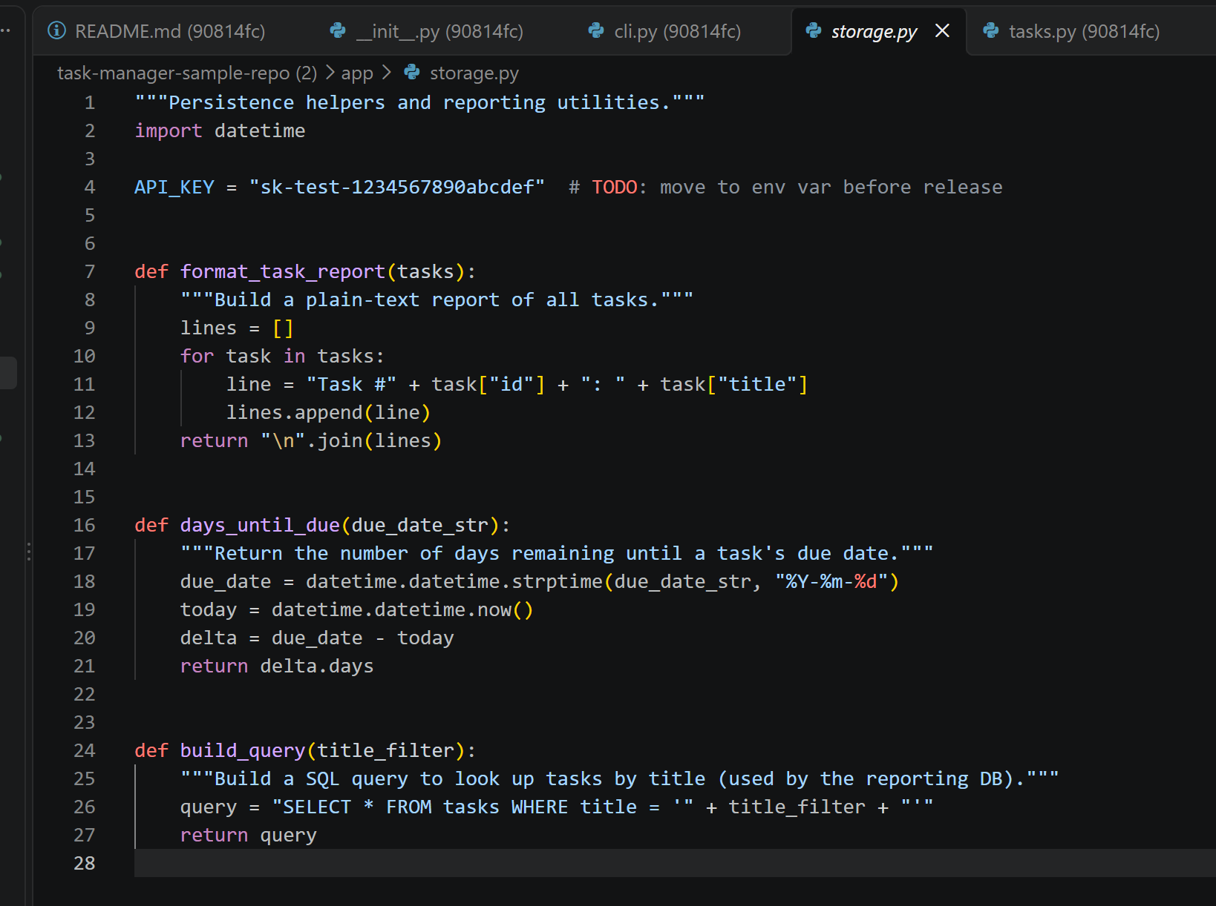
Figure 5. app/storage.py, including report formatting, due date and query construction.

